**Command Injection**

**DVWA**

**Procedure:**

1.Enter the Ip address

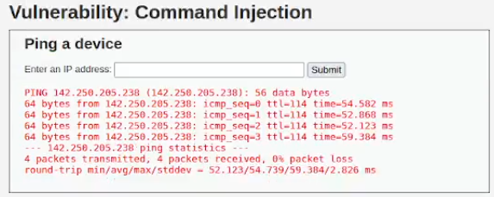

It will return 4 responses. The ping command is used here.

2.Check bottom of the page there is a php code let analyze that code

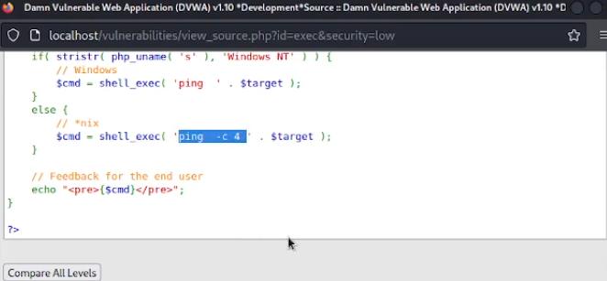

3.use whoami command to check who is the user?

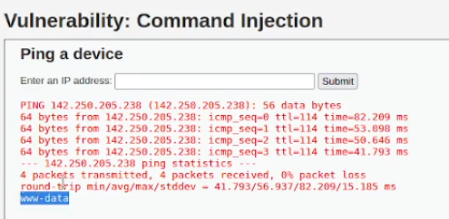

www.data is shown. We clearly understand that this machine is vulnerable to command injection.

4. I used pwd command to print the current working directory.

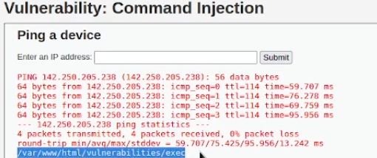

It will print the current directory.